Pneumomediastinum and Pneumothorax Induced by Rupture of a Pulmonary Hydatid Cyst: A Rare Case Report

Fariba Rezaeetalab¹, Farid poursadegh ², Marzie Noori ³,Amir Hossein Jafarian⁴ , Farzaneh Akbari⁵
- Professor of pulmonology and intensive care unit, Lung diseases Research center, Mashhad University of Medical Sciences, Mashhad, Iran , Email: rezaitalabf@mums.ac.ir
- Assistant Professor of pulmonology and intensive care unit, Lung diseases Research center, Mashhad University of Medical Sciences, Mashhad, Iran
- Chest surgeon ,Faculty of Medicine, Mashhad University of Medical Sciences, Mashhad, Iran
- Professor of Cancer pathology, Molecular Research Center, Mashhad University of Medical Sciences, Mashhad, Iran
- Internist, Faculty of Medicine, Mashhad University of Medical Sciences, Mashhad, Iran.

Abstract:

Pneumomediastinum and pneumothorax are rare complications of pulmonary hydatid cyst rupture. Hydatid disease is a parasitic disease commonly caused by Echinococcus granulosus . This parasite is transmitted to humans by direct contact with dogs or by eating vegetables and foods contaminated with their feces containing Echinococcus eggs. This case presented Pneumomediastinum and pneumothorax due to hydatid cyst rupture.

Case presentation:
A febrile 21-year-old male referred emergency room with acute onset respiratory distress and severe dyspnea . The patient did not have unremarkable medical and surgical history and perfect healthy man . Physical examination showed cyanosis and air in the arms and trunk. Lung sound was diminished. Vital sign : T= 38.7, RR= 30/min , PR=120 BP= 80/60 . Air lucencies was seen in soft tissue and pneumothorax . CT scan showed vigorous subcutaneous and soft tissue air , pneumothorax pneumomediastinum and discrete cyst in the parynchymal lung (Figure1). He admitted in ICU and applied oxygen therapy and chest tube insertion .
Lab parameters :
WBC=13.9 x 10^3/μL (4.4 - 11.3)
RBC 5.16 x 10^6/μL (4.5 - 5.9)
Hb 15.3 g/dL (12.3 - 15.3)
Platelet 579 x 10^3/μL (150 - 450)
Neut 78.9 % (45.5 - 73.1)
Lymph 16.0 % (20 – 45)
Mixed (Mono+Eos+Baso) 5.1 % (6 - 15) , HAT for hydatic cyst = 9 (up to 11)
CRP= 107.3 mg/L (0 - 10) Urea=24 Cr=o.9 FBS =108 mg/dl
Blood culture= negative . We consulted with chest surgeon and thoracotomy was performed (2). Pathologist reported and confirmed hydatid cyst (3).

Discussion:

Pneumothorax and pneumomediastinum are uncommon but serious complications of pulmonary hydatid cysts caused by the parasitic infection Echinococcus granulosus (1). Hydatid disease predominantly affects the liver and lungs; however, rupture of cysts into the pleural cavity or mediastinum may lead to significant clinical manifestations and emergencies. The rupture of a pulmonary hydatid cyst results in the leakage of air and cystic contents into the pleural space, leading to pneumothorax. Similarly, rupture into the mediastinum can cause pneumomediastinum. Such ruptures may occur spontaneously or following trauma, infection, or increased intrathoracic pressure (2). The cyst wall’s fragility and increased tension from cyst growth predispose to rupture. Patients typically present with acute chest pain, dyspnea, cough, and sometimes subcutaneous emphysema. Radiological imaging, particularly chest X-ray and CT scan, is essential for diagnosis, revealing signs of pneumothorax or pneumomediastinum along with characteristic cystic lesions (3). CT imaging offers detailed visualization of cyst rupture and its complications Management requires prompt intervention, beginning with stabilization via oxygen supplementation and chest tube drainage to manage pneumothorax. Definitive treatment involves surgical excision of the cyst and repair of the lung parenchyma to prevent recurrence and secondary complications such as infection or anaphylactic reactions (2,3). Additionally, antiparasitic therapy with albendazole is advised postoperatively to reduce recurrence risk (4) This case emphasizes the need for clinicians to consider hydatid cyst rupture in patients presenting with pneumothorax or pneumomediastinum, especially in endemic regions. Early recognition and combined surgical and medical treatment are crucial for optimal outcomes.
Conclusion: Air in mediastinum and pleural cavity are rare complications of parenchymal hydatic cyst rupture.

Key words: pneumomediastinum, Pneumothorax , Hydatid cyst

- Eslamian R, Moslemi S, Sharghi S A , Fazeli A R. A Rare Case of Pneumothorax Caused by Ruptured Pulmonary Hydatid Cysts Accompanied by Deep Vein Thrombosis:A Case Report. Acad J Surg 2024; 7(3): 59-64,
- Shameem M, Bhargava R , Fatima N, Nazir shah N. Mediastinal hydatid cyst rupturing into the pleural cavity associated with pneumothorax. Can Respir J 2006;13(4):211-213.
- Msougar Y, Afandi O, Ihfa N, Baiz Y, Rouiessi Y, Khellouki M, et al. Hydatid cyste: a case report . J Med Case Rep 2013 ;&:236.
- Sarkar M, Pathania R, Jhobta A, Thakur BR, Chopra R. Lung India. 2016 Mar-Apr;33(2):179-91.

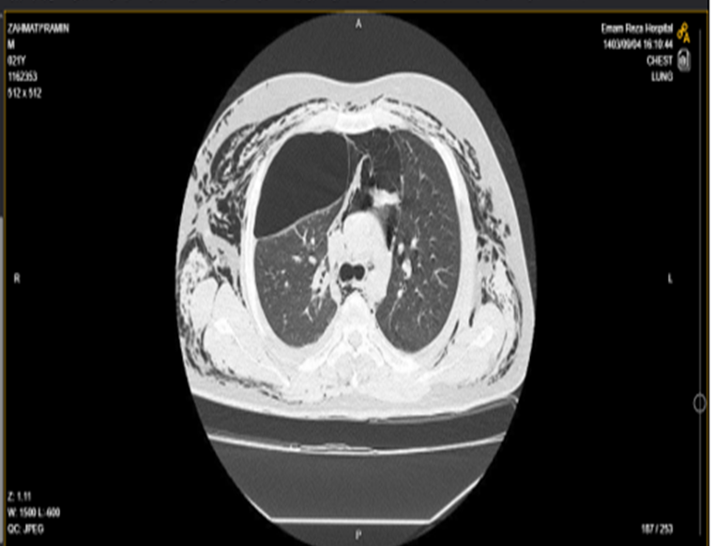

Figure 1. Lung CT scan

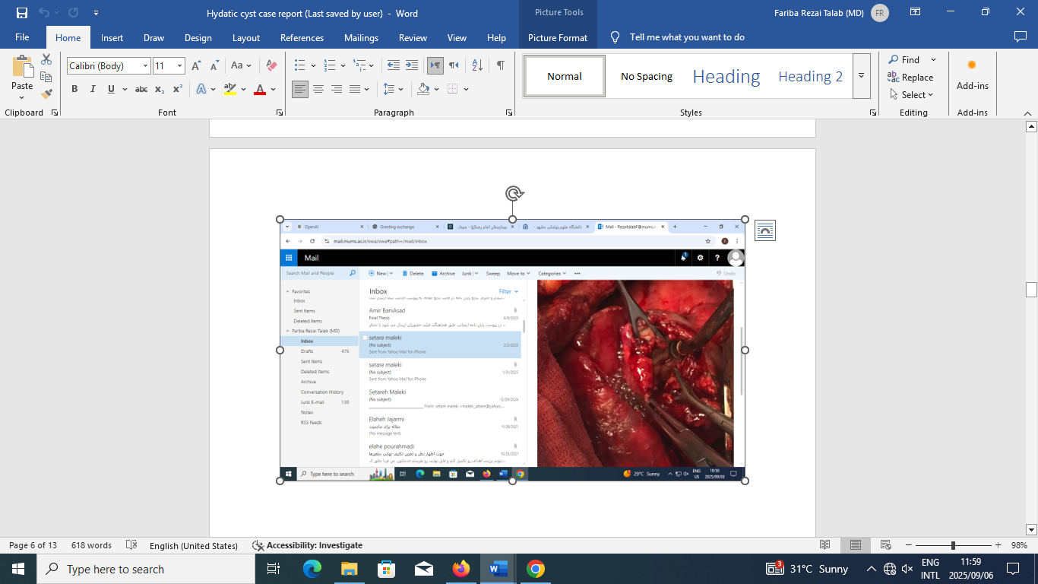

Figure 2. surgery of hydatic cyst

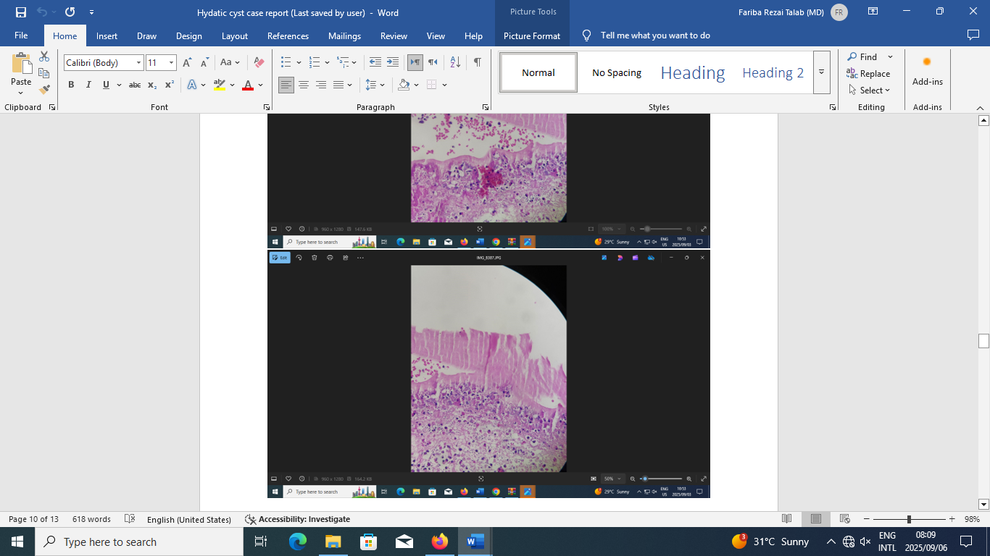
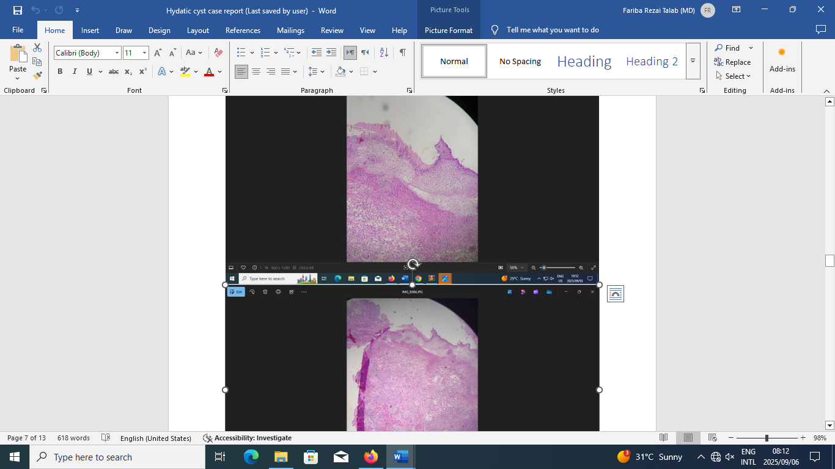

Figure3. Pathology of hydatic cyst

