COVID-19 Severity and Prognosis Prediction: An Investigation of The Current Available Criteria

Mohammad Haghighi 1, Lida Jarahi 2, Keivan Lashkari Bavil Oliiaii 3, AmirAli Moodi Ghalibaf 4, Ali Shamshirian 5 , Mahnaz Mozdourian *6

1-Department of Internal Medicine, Faculty of Medicine, Mashhad University of Medical Sciences, Mashhad, Iran.
2 -Department of Social Medicine, Faculty of Medicine, Mashhad University of Medical Sciences, Mashhad, Iran.
3- Student Research Committee, Ardabil University of Medical Sciences, Ardabil, Iran.
4- Student Research Committee, Birjand University of Medical Sciences, Birjand, Iran.
5 -Student Research Committee, Faculty of Medicine, Mashhad University of Medical Sciences, Mashhad, Iran.
6- Lung Diseases Research Center, Mashhad University of Medical Science, Mashhad, Iran.

Abstract
Introduction: Since its prevalence, Covid-19 has become one of the biggest health problems around the world, which has resulted in the loss of millions of lives. Considering preventive measures, both virulence and contagion of the disease must be considered the first essential step in reducing the burden of the disease and its mortality; therefore, the present study is to determine the epidemiological characteristics affecting the survival rate and severity of Covid- 19 in 564 patients hospitalized in Imam Reza (AS) Mashhad Hospital, in a one-year-period since 2020 .
Methods: Patients admitted to the COVID-19 wards of Imam Reza (AS) Hospital in the period from March 2020 to January 2021 were included in the study and after collecting information through the designed checklist, the obtained data was entered into SPSS 26 software and analyzed statistically.
Results: Out of 564 patients with a mean (standard deviation) age of 58.8 (16.7) years, 338 (59.9%) were male. A significant relationship was observed between increasing age, male gender, underlying hypertension disease, the duration of symptoms until hospitalization, NEWS score before hospitalization and the increase in the mortality rate of patients (p<0.05). Also, the strongest relationship was observed between increasing age and mortality (P-value = 0.001 and df = 65.9, and 95%CI = 6.6-18.2).
Conclusion: As people over the age of 50 alongside patients with underlying disease are at a higher risk of getting affected, special measures and policies must be considered in this matter. Also, using the NEWS scoring system can help in predicting the prognosis of the disease.

Introduction
COVID-19 is an infectious disease caused by Severe Acute Respiratory Syndrome Coronavirus 2 (SARS-CoV-2) that has led to a global pandemic during the years 2019 to 2022. Previously, a virus from the coronavirus family was the cause of Severe Acute Respiratory Syndrome (SARS) outbreak that rapidly spread from southern China in 2003, infecting more than 3,000 people and causing death in 774 people by the year 2004; additionaly, no similar cases regarding this individual type of coronavirus family were reported since then (1-3). In 2012, another coronavirus outbreak led to Middle East Respiratory Syndrome (MERS), which started in Saudi Arabia a total of 2,465 cases were diagnosed, resulting in 858 deaths by 2019 (4).
The first COVID-19 patients were identified in Wuhan, China. This disease is zoonotic, and the most common type of transmission from person to person is through being contacted the respiratory droplets of infected individuals. The incubation period of the disease is 4-5 days in most patients, and in some cases, it could lengthen up to14 days after the initial exposure (5, 6). COVID-19 can cause various symptoms in different organs of the body. The initial manifestations reported in studies include coughing in 54%, fever in 58%, shortness of breath in 30%, myalgia in 16%, neurological symptoms in 20%, sore throat in 14.41% and diarrhea in 9% of patients. However, studies have shown that these symptoms can become chronic in up to 60% of cases (7, 8). Some infected patients may also be asymptomatic but manifest abnormal paraclinical findings (9). Severity of the disease could range from mild to moderate, severe, and critical (respiratory failure, shock, and multi-organ dysfunction). Mild to moderate cases can be treated on an outpatient basis, while severe and critical cases require hospitalization (10).
Since the beginning of the outbreak, various treatment plans have been applied alongside supportive measures. Hydroxychloroquine was widely used in the early stages of the disease, but clinical trial studies did not show any clinical benefits from its usage (11-13). Although previous studies have sought to identify and express the factors affecting the severity of COVID-19 disease and the survival of affected patients, diverse results have been observed in these studies. While in the study by Azbakhsh et al. in 2021, increase in age was introduced as the most important factor in the occurrence of more severe symptoms (14); in 2020, male gender and having an underlying disease were introduced as the factors with higher validity in determining the severity of the disease and the survival of COVID-19 patients (15). However, the study by Wang et al. in 2020 identified the presence of underlying diseases such as hypertension, cardiovascular disease and diabetes as the main factor in reducing the survival of COVID- 19 patients (16).
In general, it can be said that despite the great efforts made so far, a definitive and completely effective treatment to improve the clinical symptoms of COVID-19 disease has not yet been found. Despite the initiation of vaccination with vaccines produced by various companies in many countries, including Iran, the extent of their effectiveness and long-term complications are still unknown. The first and essential step to reduce the burden of the disease and its damages in various economic, social, health, and treatment areas is prevention. Overtime, proper policies in the matters of prevention, epidemiological approach and identifying severity of the disease have been accomplished. Considering the scattered and contraindicatory findings regarding the factors affecting the severity of COVID-19 disease and the survival of patients infected with this virus, the present study was designed to determine the epidemiological characteristics and factors affecting the survival and severity of COVID-19 disease in 564 hospitalized patients at Imam Reza (AS) Hospital in Mashhad during 2019-2020.
Materials and Methods
The present cross-sectional (descriptiveanalytical) study was conducted in the COVID-19 wards 1 and 2 of Imam Reza (AS) Specialized and Super-Specialized Hospital in Mashhad, one of the referral hospitals in Khorasan Razavi province for COVID-19 patients. All hospitalized patients during the period from March 2020 to January 2021 were included in the study using the census method. Patients were transferred to one of the COVID-19 wards 1 to 5 after admission in the emergency department, depending on the available unoccupied beds. After the initial examination of the patients, their bibliography, including age, gender, disease symptoms, the duration of symptoms until hospital admission, history of previous illness, history of medications used, history of contact with a patient infected or suspected of COVID-19 within 14 days before admission, history of travel within 14 days before admission, history of smoking and drug addiction, vital signs at the time of admission, lung involvement score in CT scan, C-reactive protein (CRP) at the time of admission, and scores based on the qSOFA (Quick Sequential Organ Failure Assessment) and NEWS (National Early Warning Score) scoring systems, were entered into the checklist. During hospitalization, were monitored to the Intensive Care Unit (ICU) and the duration of hospitalization until death or discharge. The qSOFA, introduced in 2016 to facilitate the identification of patients high risk of death from sepsis, was after the Sequential Organ Failure Assessment (SOFA). This scoring system consists of three characteristics: respiratory rate greater than 21, mental status changes and alertness, and blood pressure less than or equal to 100 mmHg, with one score assigned to each of these three characteristics (17). The NEWS is another system for identifying patients at risk of relapse, which assigns a score to each of the following findings: level of consciousness, heart rate, systolic blood pressure, respiratory rate, temperature, oxygen saturation (18). Severe cases based on a qSOFA score ≥2 or a NEWS score ≥7, a lung involvement score ≥16 in the CT scan, the need for intensive care in the ICU during hospitalization, and death. The obtained data were entered into the SPSS 26 software. T-test was used to compare quantitative variables, and chi-square test was used for qualitative variables. A P-value of < 0.05 was considered statistically significant. In cases where a statistically significant difference was found, the odds ratio (OR) was also calculated.
Results
Out of 564 hospitalized patients, 338 (59.9%) were male and 226 (40.1%) were female. The mean and standard deviation of the patients' age was 58.8 ± 16.7 years. The youngest hospitalized patient was 20 years old and the oldest was 97 years old. The mean and standard deviation of the length of hospital stay for the patients was 12.0 ± 9.4 days. The most common underlying diseases the patients were hypertension in 295 (52.3%) patients, diabetes in 227 (40.2%) patients, and ischemic heart disease in 162 (28.7%) patients. The frequency of other diseases is shown in Table 1.
The most common clinical symptoms of the patients were shortness of breath in 464 (82.3%), fever in 423 (75.0%), and weakness in 388 (59.4%) patients. The frequency of other clinical symptoms is shown in Table 2 (Tables 1 and 2). The mean and standard deviation of the time from symptom onset to hospital admission was 11.8 ± 7.5 days. None of the patients reported a history of contact with an infected or suspected person within 14 days before admission. None of the patients had a history of travel within 14 days before admission. The mean and standard deviation of the patients' arterial oxygen saturation (O2Sat) at the time of hospital admission was 82.7 ± 7.6 percent. The mean and standard deviation of CRP at the time of admission was 108.5 ± 80.8. The mean and standard deviation of the lung involvement severity score was 12.2 ± 4.9. 167 patients (29.6%) had a lung involvement severity score of ≥16 and were in the severe lung involvement group. 268 patients (47.6%) had moderate (16-9) and 129 patients (22.8%) had mild (0-8) lung involvement. 78 patients (46.7%) with severe lung involvement required ICU admission, while a total of 45 patients (11.3%) with moderate and mild lung involvement required both ICU and intensive care, which was statistically significant based on chisquare test (P-value=0.01). The odds ratio (OR) of ICU admission for patients with severe lung involvement was 1.9 times higher than patients with mild and moderate involvement (95% CI=1.66-2.38). Based on qSOFA scoring system at the time of admission, 56 patients (9.9%) were in the high-risk group for morbidity and mortality, of whom 38 patients (6.7%) required ICU admission. According to chi-square test, the difference between the high-risk and low-risk groups based on qSOFA scoring system and ICU admission was not statistically significant (P-value=0.124). The mean and standard deviation of the patients' NEWS score was 7.8 ± 2.3. Based on the NEWS scoring system, 458 patients (81.2%) were in the high-risk group for morbidity and mortality. Of these, 118 patients (20.9%) required ICU admission.
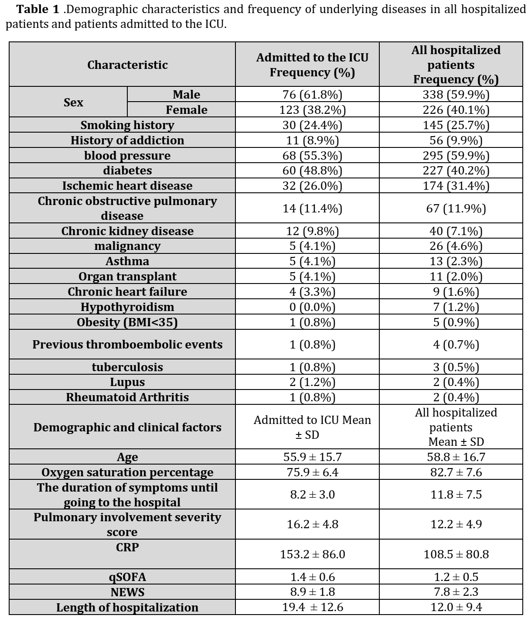
According to chi-square test, there was a significant difference between patients with a NEWS score ≥7 who required ICU admission and patients with a NEWS score less than 7 who required ICU admission (Pvalue=0.001). The odds ratio (OR) of ICU admission for patients with a NEWS score ≥7 compared to patients with a NEWS score less than 7 was 1.4 (95% CI=1.24-1.46). Table 3.
123 patients required ICU admission from whom, 76 were male (61.8%) and 47 were female (38.2%). The mean and standard deviation of the age of the patients transferred to the ICU was 55.9 ± 15.7 years. The mean and standard deviation of the duration from symptom onset to hospital admission was 8.2 ± 3.0 days. The mean and standard deviation of the patients' oxygen saturation at the time of admission was 75.9 ± 6.4 percent. The mean and standard deviation of CRP in the patients at the time of admission was 153.2 ± 86.0.
Table 2 .Frequency of clinical symptoms in hospitalized patients.
Clinical sign | All hospitalized patients Frequency (%)
Shortness of breath | 464 (82.3%)
Fever | 423 (75.0%)
weakness | 388 (68.8%)
Cough | 335 (59.4%)
Chest pain | 304 (53.9%)
Headache | 301 (53.4%)
nausea and vomiting | 228 (40.4%)
myalgia | 220 (39.0%)
Loss of consciousness | 90 (15.9%)
Arthralgia | 73 (12.9%)
diarrhea | 52 (9.2%)
stomach ache | 35 (6.2%)
Sore throat | 31 (5.5%)
Decreased smell | 22 (3.9%)
Unpleasant taste sensation | 16 (2.8%)
Rhinorrhea | 4 (0.7%)
conjunctivitis | 3 (0.5%)
The mean and standard deviation of the lung involvement severity score of the patients was 16.2 ± 4.8. The mean and standard deviation of the qSOFA score of the patients at the time of admission was 1.4 ± 0.6. The mean and standard deviation of the NEWS score of the patients at the time of admission was 8.9 ± 1.8. The mean and standard deviation of the length of hospital stay for the patients was 19.4 ± 12.6 days. The most common comorbidities in these patients were hypertension in 68 patients (55.3%), diabetes in 60 patients (48.8%), and ischemic heart disease in 32 patients (26.0%). The frequency of other underlying diseases is shown in Table 1. 25 patients (20.3%) had no underlying disease. 25 patients (20.3%) had one underlying disease. 45 patients (36.6%) had two underlying diseases. 28 patients (22.8%) also had three or more underlying diseases. 30 patients (24.4%) had a history of smoking, and 11 patients (8.9%) reported a history of drug addiction. The severity of lung involvement was mild in 8 patients (6.4%), moderate in 38 patients (31.0%), and severe in 77 patients (62.6%). Based on qSOFA score, 38 patients (30.9%) were in the high-risk group, and based on NEWS score, 118 patients (95.9%) were in the high-risk group. (Tables 1 and 2).
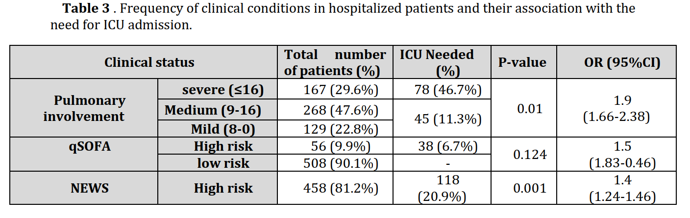
Ultimately, 87 patients (15.4%) of the patients who required transfer to the ICU during their hospitalization died. 63 patients (72.8%) of these deceased patients had severe lung involvement, and in the other 24 patients (27.2%), the severity of lung involvement was mild or moderate. Based on the chi-square test, there was no statistically significant relationship between mild and moderate (<16) or severe (≥16) lung involvement and patient mortality (Pvalue=0.054). 86 patients (98.8%) of the deceased patients had a NEWS score above 7, and based on the chi-square test, there was a statistically significant relationship between the NEWS score and patient mortality (Pvalue=0.011). The odds ratio (OR) of death in individuals with a NEWS score ≥7 is 2.9 times higher than in those with a NEWS score less than 7 (95% CI=1.73-5.00). 59 patients (67.8%) of the deceased patients were male. Based on the chi-square test, there was a statistically significant relationship between patient gender and mortality rate (P-value=0.032). The odds ratio (OR) of death in men is 1.3 times higher than in women (95% CI=1.00-1.69). 60 patients (69.9%) of the deceased patients had 2 or more underlying diseases. 56 patients (64.3%) of the deceased patients had hypertension, and 47 patients (54.0%) had diabetes. Based on the chi-square test, a statistically significant relationship was only observed between hypertension and mortality rate (P-value=0.002). For other underlying diseases listed in Table 1, this difference was not statistically significant. 23 patients (26.4%) of the deceased patients were smokers. The relationship between smoking and patient mortality was not statistically significant. 63 patients (72.4%) of the ICU patients who died had a history of using antihypertensive medications. Based on chi-square test, there was a statistically significant relationship between the use of antihypertensive
medications and patient mortality (Pvalue=0.003). 52 patients (59.7%) of the
deceased patients were taking ACEI (Angiotensin-converting enzyme inhibitors)
or ARB (Angiotensin receptor blockers) medications. Based on the chi-square test,
there was a statistically significant relationship between the use of ACEI or ARB antihypertensive medications and patient mortality (P-value=0.035). For other medications used by the patients, there was no statistically significant relationship with mortality. The mean and standard deviation of the age of the patients who died after transfer to the ICU was 59.6 ± 14.7 years, and in the patients who were discharged, it was 47.1 ± 14.6 years. Based on t-test, there was a statistically significant relationship between the mean age of the patients and mortality (Pvalue=0.001, df=165, 95% CI=-18.6 to -6.9). The mean and standard deviation of the time from symptom onset to hospital admission in the patients who died after transfer to the ICU was 8.6 ± 3.3 days, and in the patients who were discharged, it was 7.1 ± 1.8 days. Based on t-test, there was a statistically significant relationship between the mean time from symptom onset to hospital admission and patient mortality (Pvalue=0.013, df=112.6, 95% CI=-2.4 to -0.56). (Table 3)
Discussion
The results of this study are largely coherent with other studies conducted over COVID-19. According to the study by Bolut et al. in 2020, the age group which was mostly affected in Italy, Spain, and the Netherlands was 50-59 years, followed by 60-69 years. The reason for the higher involvement of the elder group in COVID-19 in studies has also been attributed to having more underlying diseases and a weaker immune system (19, 20). In similar studies like the one by Cunningham et al., men were more affected than women (21). In studies conducted by Imami et al. in 2020, the study by Zad et al. in 2020, and also by Yang et al. in 2020, the most common underlying diseases accompanying COVID-19 were hypertension, cardiovascular diseases, diabetes, chronic obstructive pulmonary disease, malignancy, and chronic kidney failure, which is coherent with the results of our study (10, 22, 23). The findings of this study indicate a relationship between hypertension and disease severity, which is in line with the findings of the studies by Guan et al. and Reynolds et al. in 2020 (24, 25). In many of the studies conducted, there was no relationship between the use of blood pressure-lowering drugs, especially ACEIs and ARBs, and disease severity, and the results of our study are not in resemblance with these studies, which may be due to lack of similar studied population. It should also be noted that consumers of these types of antihypertensive drugs suffer from hypertension, which increases the risk of complications and mortality from COVID-19 (26-28). The most common clinical symptoms of hospitalized patients were shortness of breath, fever, and cough, which are consistent with other studies (7). None of the patients reported a history of contact with an infected or suspected person, which may be due to various reasons such as lack of awareness of the patient's illness in the surrounding people, lack of awareness of ways of transmission of the disease, or exposure to asymptomatic carriers. The average time from symptom onset to hospital admission and hospitalization was more than 7 days. In various studies, the initial CRP level of patients has been associated with disease severity, with levels above 50-60 being considered an independent predictor of disease severity (29, 30). In this study, the average initial CRP of patients was also high, and for patients requiring ICU admission, it was 153. Other studies have also confirmed the increase in CRP during COVID-19, and have indicated the association between high CRP levels and more severe pulmonary involvement and worse prognosis (31, 32). In the study by Wu et al., pulmonary involvement >50% was considered severe (10), and based on the European Radiology Association scoring system, a score >15 (out of 24) was considered severe, which was also the way of measurement in our study (33). In the study by Mitra et al (34), the qSOFA scoring system did not have sufficient sensitivity in predicting in-hospital mortality, which is consistent with the results of this study (34), but in the study by Sijia et al., qSOFA at admission was associated with inhospital mortality of COVID-19 patients, although it had lower sensitivity than SOFA (35). In the study by Harry et al., qSOFA predicted mortality better than SIRS (36). In a meta-analysis by Fernando et al., although qSOFA had lower sensitivity than SIRS in predicting sepsis-related mortality, it had higher specificity (37). The reason for this difference can be considered in the timing of calculating this criterion in patients, as mentioned in the Mitra study (34) , the lower sensitivity of qSOFA in ICU patients may be due to receiving mechanical ventilation or vasopressors, which reduces the clinical value of this criterion (34). Similar studies have used arterial oxygen saturation (O2sat <93%) to determine severe cases of the disease (10), and in our study, the NEWS scoring system was used, which in addition to arterial oxygen saturation, includes respiratory rate (RR), heart rate (PR), systolic blood pressure (SBP), level of consciousness, body temperature, and the need for supplemental oxygen in admission, and has been used since 2016 to mortality rate of non-ICU patients during hospitalization (38). In this system, scores of 0 to 4 are considered low-risk for mortality, scores of 5 and 6 are moderate-risk, and scores of 7 to 20 are highrisk. Previous studies have shown the relationship between patient scores based on this scoring system and the rate of ICU admission and mortality (39). The results of our study also showed this relationship, and patients with a NEWS score <6 had 2.9 times more need for ICU admission. This finding of the present study is in line with the results of a study by Baker et al. in 2021, which showed that the NEWS2 criterion has sufficient sensitivity to detect worsening of hospitalized COVID-19 patients. This criterion also performed better than NEWS and qSOFA, although the authors of this study consider the use of only one of these mentioned criteria to be incorrect (40). The incidence of the disease has been higher in men, and middle-aged and elderly individuals have been the largest age group involved in the first, second, and third peaks of the COVID-19 pandemic. On the other hand, underlying diseases are also more commonly seen in these age groups. Therefore, these age groups, especially individuals with underlying conditions, require more attention in health policymaking and prioritization. As none of the patients in our study had a history of getting in contact with an infected or suspected individual, conducting studies to determine the level of awareness, insight, and performance of individuals in different social, economic, and cultural groups could be helpful. The results of these studies can be used in planning public education programs for prevention of infection and making these education programs more practical based on the target audience. The time between symptom onset and hospital admission is important for two reasons; First, delayed presentation (or referral) of the patient to the hospital in the early stages of the disease reduces the chances of successful treatment and increases the likelihood of complications, prolonged hospitalization and the need for supportive measures. On the other hand, given the existing infrastructure in different social and economic strata and the ability to properly quarantine patients at home, the likelihood of disease transmission to other individuals during this period also decreases. In this regard, conducting further studies and examining the infrastructure and available facilities in urban and rural communities for planning and determining practical preventive strategies seems necessary. The average initial CRP level of patients is high, which can indicate delayed hospital presentation and be a predictor of disease severity. CRP can be used as an independent predictor of disease severity and can even be used to monitor patients before referral to the hospital. Although the use of the qSOFA score for patient assessment is easy and can be used even by common folk, it does not have adequate clinical efficacy. The NEWS scoring system for initial patient assessment and prioritization of service delivery with minimum required equipment (blood pressure monitor and pulse oximeter) can be used at different levels of healthcare and can help in time-consuming referral of patients to the hospital for receiving treatment. There is hope that with appropriate preventive measures such as adherence to health protocols and vaccination, the disease transmission cycle can be stopped. However, early diagnosis of patients and identifying the patients in need of treatment promptly would contribute to the success of treatment and reduction of disease burden.
Acknowledgments
The authors express their deepest gratitude to all the staff and patients who collaborated in conducting this study.

References
1. Shaw K. The 2003 SARS outbreak and its impact on infection control practices. Public health. 2006 Jan 1;120(1):8-14.
2. Organization WH. SARS (Severe Acute RespiratorySyndrome). 2019.
3. Saeedi N, Gohari NS, Ghalibaf AA, Dehghan A, Owlia MB. COVID-19 infection: a possible induction factor for development of autoimmune diseases?. Immunologic Research. 2023 Aug;71(4):547-53.
4. Matsuyama R, Nishiura H, Kutsuna S, Hayakawa K, Ohmagari N. Clinical determinants of the severity of Middle East respiratory syndrome (MERS): a systematic review and meta-analysis. BMC public health. 2016 Dec;16:1-0.
5. Hui DS, Azhar EI, Madani TA, Ntoumi F, Kock R, Dar O, et al. The continuing 2019-nCoV epidemic threat of novel coronaviruses to global health— The latest 2019 novel coronavirus outbreak in Wuhan, China. International journal of infectious diseases. 2020 Feb 1;91:264-6.
6. Lauer SA, Grantz KH, Bi Q, Jones FK, Zheng Q, Meredith HR, et al. The incubation period of coronavirus disease 2019 (COVID-19) from publicly reported confirmed cases: estimation and application. Annals of internal medicine. 2020 May 5;172(9):577-82.
7. da Rosa Mesquita R, Francelino Silva Junior LC, Santos Santana FM, Farias de Oliveira T, Campos Alcântara R, Monteiro Arnozo G, et al. Clinical manifestations of COVID-19 in the general population: systematic review. Wiener klinische Wochenschrift. 2021 Apr;133(7):377-82.
8. Fernández-de-Las-Peñas C, Palacios-Ceña D, Gómez-Mayordomo V, Florencio LL, Cuadrado ML, Plaza-Manzano G, Navarro-Santana M. Prevalence of post-COVID-19 symptoms in hospitalized and non-hospitalized COVID-19 survivors: A systematic review and meta-analysis. European journal of internal medicine. 2021 Oct 1;92:55-70.
9. Oran DP, Topol EJ. Prevalence of asymptomatic SARS-CoV-2 infection: a narrative review. Annals of internal medicine. 2020 Sep 1;173(5):362-7.
10. Wu Z, McGoogan JM. Characteristics of and important lessons from the coronavirus disease 2019 (COVID-19) outbreak in China: summary of a report of 72 314 cases from the Chinese Center for Disease Control and Prevention. jama. 2020 Apr 7;323(13):1239-42.
11. RECOVERY Collaborative Group. Effect of hydroxychloroquine in hospitalized patients with Covid-19. New England Journal of Medicine. 2020 Nov 19;383(21):2030-40.
12. Pathak SK, Salunke AA, Thivari P, Pandey A, Nandy K, Ratna HV, et al. No benefit of hydroxychloroquine in COVID-19: results of systematic review and meta-analysis of randomized controlled trials”. Diabetes & Metabolic Syndrome: Clinical Research & Reviews. 2020 Nov 1;14(6):1673-80.
13. Niroumand S, Mastour H, Ghalibaf AM, Shamshirian A, Moghadasin M. Medical Students' Attitude Toward E-learning During the COVID-19 Pandemic. Shiraz E-Medical Journal. 2022;23(9).
14. Azarbakhsh H, Jokari K, Moftakhar L, Ghojogh MG, Karimyan A, Salmanzadeh S, et al. Epidemiological characteristics of patients with COVID-19 in Southwest of Iran from February 19 to June 20, 2020. Medical journal of the Islamic Republic of Iran. 2021;35:116.
15. Nikpouraghdam M, Farahani AJ, Alishiri G, Heydari S, Ebrahimnia M, Samadinia H, et al. Epidemiological characteristics of coronavirus disease 2019 (COVID-19) patients in IRAN: A single center study. Journal of Clinical Virology. 2020 Jun 1;127:104378.
16. Wang F, Cao J, Yu Y, Ding J, Eshak ES, Liu K, et al. Epidemiological characteristics of patients with severe COVID-19 infection in Wuhan, China: evidence from a retrospective observational study. International journal of epidemiology. 2020 Dec 1;49(6):1940-50.
17. Marik PE, Taeb AM. SIRS, qSOFA and new sepsis definition. Journal of thoracic disease. 2017 Apr;9(4):943.
18. Abbott TE, Vaid N, Ip D, Cron N, Wells M, Torrance HD, et al. A single-centre observational cohort study of admission National Early Warning Score (NEWS). Resuscitation. 2015 Jul 1;92:89-93.
19. COVID-19 Information for Older Adults | cdc. wwwcdcgov. 2021.
20. Bulut C, Kato Y. Epidemiology of COVID-19. Turkish journal of medical sciences. 2020;50(9):563-70.
21. Cunningham JW, Vaduganathan M, Claggett BL, Jering KS, Bhatt AS, Rosenthal N, et al. Clinical outcomes in young US adults hospitalized with COVID-19. JAMA internal medicine. 2021 Mar 1;181(3):379-81.
22. Emami A, Javanmardi F, Pirbonyeh N, Akbari A. Prevalence of underlying diseases in hospitalized patients with COVID-19: a systematic review and meta-analysis. Archives of academic emergency medicine. 2020;8(1).
23. Yang J, Zheng YA, Gou X, Pu K, Chen Z, Guo Q, et al. Prevalence of comorbidities and its effects in patients infected with SARS-CoV-2: a systematic review and meta-analysis. International journal of infectious diseases. 2020 May 1;94:91-5.
24. Guan WJ, Liang WH, Zhao Y, Liang HR, Chen ZS, Li YM, et al. Comorbidity and its impact on 1590 patients with COVID-19 in China: a nationwide analysis. European Respiratory Journal. 2020 May 1;55(5).
25. Reynolds HR, Adhikari S, Pulgarin C, Troxel AB, Iturrate E, Johnson SB, et al. Renin– angiotensin–aldosterone system inhibitors and risk of Covid-19. New England Journal of Medicine. 2020 Jun 18;382(25):2441-8.
26. Hippisley-Cox J, Young D, Coupland C, Channon KM, San Tan P, Harrison DA, et al. Risk of severe COVID-19 disease with ACE inhibitors and angiotensin receptor blockers: cohort study including 8.3 million people. Heart. 2020 Oct 1;106(19):1503-11.
27. Mackey K, King VJ, Gurley S, Kiefer M, Liederbauer E, Vela K, et al. Risks and impact of angiotensin-converting enzyme inhibitors or angiotensin-receptor blockers on SARS-CoV-2 infection in adults: a living systematic review. Annals of internal medicine. 2020 Aug 4;173(3):195-203.
28. Pranata R, Lim MA, Huang I, Raharjo SB, Lukito AA. Hypertension is associated with increased mortality and severity of disease in COVID-19 pneumonia: a systematic review, metaanalysis and meta-regression. Journal of the renin-angiotensin-aldosterone system: JRAAS. 2020 Apr;21(2).
29. Ahnach M, Zbiri S, Nejjari S, Ousti F, Elkettani C. C-reactive protein as an early predictor of COVID-19 severity. Journal of medical biochemistry. 2020 Oct 10;39(4):500.
30. Chen W, Zheng KI, Liu S, Yan Z, Xu C, Qiao Z. Plasma CRP level is positively associated with the severity of COVID-19. Annals of clinical microbiology and antimicrobials. 2020 Dec;19:1- 7.
31. Abrishami A, Eslami V, Arab-Ahmadi M, Alahyari S, Azhideh A, Sanei-Taheri M. Prognostic value of inflammatory biomarkers for predicting the extent of lung involvement and final clinical outcome in patients with COVID-19. Journal of Research in Medical Sciences. 2021 Jan 1;26(1):115.
32. Sahu BR, Kampa RK, Padhi A, Panda AK. Creactive protein: a promising biomarker for poor prognosis in COVID-19 infection. Clinica chimica acta. 2020 Oct 1;509:91-4.
33. Francone M, Iafrate F, Masci GM, Coco S, Cilia F, Manganaro L, et al. Chest CT score in COVID-19 patients: correlation with disease severity and short-term prognosis. European radiology. 2020 Dec;30:6808-17.
34. Maitra S, Som A, Bhattacharjee S. Accuracy of quick Sequential Organ Failure Assessment (qSOFA) score and systemic inflammatory response syndrome (SIRS) criteria for predicting mortality in hospitalized patients with suspected infection: a meta-analysis of observational studies. Clinical Microbiology and Infection. 2018 Nov 1;24(11):1123-9.
35. Liu S, Yao N, Qiu Y, He C. Predictive performance of SOFA and qSOFA for in-hospital mortality in severe novel coronavirus disease. The American Journal of Emergency Medicine. 2020 Oct 1;38(10):2074-80.
36. Shankar-Hari M, Phillips GS, Levy ML, Seymour CW, Liu VX, Deutschman CS, et al. Developing a new definition and assessing new clinical criteria for septic shock: for the Third International Consensus Definitions for Sepsis and Septic Shock (Sepsis-3). Jama. 2016 Feb 23;315(8):775-87.
37. Fernando SM, Tran A, Taljaard M, Cheng W, Rochwerg B, Seely AJ, et al. Prognostic accuracy of the quick sequential organ failure assessment for mortality in patients with suspected infection: a systematic review and meta-analysis. Annals of internal medicine. 2018 Feb 20;168(4):266-75.
38. Singer M, Deutschman CS, Seymour CW, Shankar-Hari M, Annane D, Bauer M, et al. The third international consensus definitions for sepsis and septic shock (Sepsis-3). Jama. 2016 Feb 23;315(8):801-10.
39. Goulden R, Hoyle MC, Monis J, Railton D, Riley V, Martin P, et al. qSOFA, SIRS and NEWS for predicting inhospital mortality and ICU admission in emergency admissions treated as sepsis. Emergency Medicine Journal. 2018 Jun 1;35(6):345-9.
40. Baker KF, Hanrath AT, van der Loeff IS, Kay LJ, Back J, Duncan CJ. National Early Warning Score 2 (NEWS2) to identify inpatient COVID-19 deterioration: a retrospective analysis. Clinical Medicine. 2021 Mar 1;21(2):84-9.

