Diaphragmatic Ultrasonography Predicts Non-Invasive Ventilation Success and Hospital Stay in Iranian COPD Patients: A Prospective Cohort Study

Amin Ranjbar ¹, Motahhareh Karimoddini², Fariba Rezaeetalab¹, Mohammad Haghighi³,
Mahnaz Mozdourian¹*

- Pulmonologist, lung diseases research center, Mashhad University of Medical Science, Mashhad, Iran.
- Internal Medicine Department, Faculty of Medicine Mashhad University of Medical Sciences Mashhad Iran.
- Assistant professor of Nephrology, Department of Internal Medicine, Faculty of Medicine, Mashhad University of Medical Sciences, Mashhad, Iran

CORRESPONDING
Mahnaz Mozdourian*: Pulmonologist, lung diseases research center, Mashhad University of Medical Science, Mashhad, Iran. / e-mail: mozdorianmh@mums.ac.ir
/ Tel: 09122965603 / Postal address: Razavi Khorasan Province, Mashhad, Ebne Sina St, Emam Reza Hospital / Postal code: 91379-13316
ORCID: https://orcid.org/0000-0002-1692-4510

Background: Acute exacerbations of COPD (AECOPD) frequently cause hypercapnic respiratory failure, necessitating non-invasive ventilation (NIV). However, NIV failure rates remain high (15-30%), partly due to diaphragmatic dysfunction. This study evaluated real-time diaphragmatic changes via ultrasonography during NIV in an understudied Iranian cohort, where environmental and resource constraints may impact outcomes.
Methods: A prospective cohort study enrolled 50 patients with AECOPD requiring NIV at two Iranian tertiary hospitals (July 2023-January 2025). Diaphragmatic parameters (end-inspiration thickness [DTei], end-expiration thickness [DTee], thickening fraction [DTF]) and venous PCO₂ were measured pre-NIV and at 48 hours. Primary outcomes included diaphragmatic/PCO₂ changes; secondary outcomes comprised NIV success (avoiding intubation + clinical improvement), hospitalization duration, and mortality. Statistical analyses included paired tests, Spearman correlations, and logistic regression.
Results: NIV significantly improved diaphragmatic function (median ΔDTF: +15.3%, *p* < 0.001) and gas exchange (mean ΔPCO₂: -18.4 mmHg, *p* < 0.001). A strong inverse correlation linked ΔDTF to PCO₂ reduction (ρ = -0.82, *p* < 0.001) and CRP (ρ = -0.71, *p* < 0.001). Baseline DTF ≥28% predicted NIV success (sensitivity: 82%; OR: 1.12 per 1% increase), while ΔDTF ≥15% reduced intubation risk by 64%. High responders (ΔDTF >15% + PCO₂ reduction >5 mmHg) had shorter hospital stays (median: 6 vs. 8 days, *p* < 0.001). Systemic inflammation (CRP >45 mg/L) and age >65 years attenuated treatment response.
Conclusion: Diaphragmatic ultrasonography identifies NIV responders and predicts hospitalization duration. Thresholds (baseline DTF ≥28%, ΔDTF ≥15%) offer clinical benchmarks for escalation decisions. Venous PCO₂ reliably monitors gas exchange, supporting resource-limited settings.

Keywords: COPD, NIV, Diaphragmatic ultrasonography, Respiratory failure, venous blood gas

Introduction
Chronic obstructive pulmonary disease (COPD) is a progressive respiratory disorder marked by persistent airflow limitation, chronic symptoms (dyspnea, cough, sputum production), and structural damage to airways/alveoli (1). A leading global cause of mortality, COPD affects over 250 million people and accounts for 3.2 million deaths annually, with projections ranking it as the third-leading cause of death by 2030 (2). The disease imposes substantial socioeconomic burdens due to high healthcare costs and reduced quality of life (3, 4).
While tobacco smoking remains the primary risk factor (5, 6), 25-45% of cases occur in non-smokers, attributable to indoor/outdoor air pollution (e.g., biomass smoke), occupational hazards (dust, chemical fumes), and host factors (age, genetics, prior lung disease) (7, 8, 9). Its multifactorial etiology underscores the need for targeted prevention strategies, particularly in low-resource settings where non-smoking risk factors predominate.
In Iran, its prevalence reaches 5-10% among adults over 40, with higher rates in urban-industrial areas due to air pollution and smoking (10). Acute exacerbations (AECOPD) often precipitate hypercapnic respiratory failure, necessitating non-invasive ventilation (NIV) as first-line therapy to reduce intubation rates and mortality (11). However, NIV failure occurs in 15-30% of cases (12), driven partly by diaphragmatic dysfunction a consequence of chronic hyperinflation, increased mechanical load, and reduced contractile efficiency (13).
The diaphragm, as the primary respiratory muscle, undergoes structural and functional adaptations in COPD, including fiber shortening and oxidative capacity reduction (13, 14). During exacerbations, these impairments worsen, leading to acute-on-chronic respiratory failure. While NIV alleviates work of breathing, its success hinges on preserved diaphragmatic function (11, 15). Traditional monitoring relies on arterial blood gas (ABG) analysis, but this is invasive and impractical for frequent assessments, especially in resource-limited settings like Iran, where venous blood gas (VBG) offers a feasible alternative (16).
Diaphragm ultrasonography has emerged as a bedside, non-invasive tool to quantify diaphragmatic performance through metrics like: Thickness at end-inspiration (DTei) and end-expiration (DTee) and Diaphragmatic thickening fraction (DTF) (17).
Studies demonstrate DTF < 36.3% predicts NIV failure (18, 19), and real-time ultrasonography can detect patient-ventilator asynchrony as a key contributor to NIV failure (20, 21). Matamis et al. further validated ultrasonography for assessing diaphragmatic dysfunction in critical illness (22), while Vivier et al. showed its utility in titrating NIV pressures by quantifying work of breathing. Despite this, most data derive from Western cohorts, neglecting populations like Iran, where environmental exposures (e.g., air pollution) and healthcare resource limitations may alter disease progression and therapeutic responses (23).
Economic and healthcare burdens compound these challenges. COPD incurs global costs exceeding $150 billion annually (3), with Iranian patients facing direct costs of 10-15 million IRR/year, primarily from hospitalization (24). Early identification of NIV non-responders via ultrasonography could reduce ICU stays and costs, particularly in settings where ABG monitoring is unsustainable (10, 16).
This prospective cohort study aimed to evaluate real-time changes in diaphragmatic function (assessed via ultrasonographic parameters DTei, DTee, and DTF during NIV in patients with AECOPD, focusing on an understudied Iranian population where genetic and environmental factors may influence outcomes. We further sought to correlate these dynamic ultrasonographic measures with NIV success and clinical outcomes, while validating VBG analysis as a practical, non-invasive alternative to arterial blood gas for monitoring PCO₂ reduction and NIV efficacy in resource-constrained settings.

Methods
Study Design and Setting
A prospective cohort study was conducted between July 2023 and January 2025 at the pulmonary medicine and intensive care units of Ghaem and Imam Reza Hospitals, tertiary referral centers affiliated with Mashhad University of Medical Sciences, Iran. These facilities serve as regional respiratory care hubs with dedicated infrastructure for NIV management and point-of-care ultrasonography, providing an appropriate clinical environment for investigating diaphragmatic dynamics during AECOPD.
Participant Selection
Consecutive adult patients (≥40 years) hospitalized with AECOPD requiring NIV intervention were screened for eligibility. COPD diagnosis was confirmed according to Global Initiative for Chronic Obstructive Lung Disease (GOLD) criteria, defined as post-bronchodilator FEV₁/FVC ratio <0.7 (25, 26). Inclusion mandated hypercapnic respiratory failure (pH <7.35 and PaCO₂ >45 mmHg) with clinical indications for NIV. Exclusion criteria comprised neuromuscular disorders (e.g., amyotrophic lateral sclerosis, myasthenia gravis) affecting diaphragmatic function, significant thoracic cage deformities (kyphoscoliosis >40°), absolute NIV contraindications (impaired consciousness [GCS <8], inability to maintain airway protection), active electrolyte disturbances (serum Na⁺ <130 mmol/L, K⁺ <3.0 mmol/L, Ca²⁺ <7.0 mg/dL, Mg²⁺ <1.5 mg/dL), substance use disorders involving opioids, or refusal to provide informed consent.
Intervention Protocol
NIV was administered using bilevel positive airway pressure (BiPAP) devices (Philips Respironics V60 or ResMed Stellar 150) initiated at standard settings of 10-12 cmH₂O inspiratory positive airway pressure (IPAP) and 4-6 cmH₂O expiratory positive airway pressure (EPAP). Pressure titration was performed by attending pulmonologists based on continuous physiological monitoring, including pulse oximetry (SpO₂), respiratory rate trends, and serial VBG analyses, consistent with GOLD guideline recommendations (25, 26). Interface selection (oronasal vs. nasal masks) was individualized for optimal patient comfort and minimal air leakage.
Measurements and Data Collection
Comprehensive baseline assessment included documentation of demographic characteristics, anthropometric measurements (BMI), and laboratory investigations comprising complete blood count (Sysmex XN-1000), inflammatory markers (C-reactive protein (CRP), Erythrocyte Sedimentation Rate (ESR), electrolyte panels (Na⁺, K⁺, Ca²⁺, Mg²⁺), albumin, and 25-hydroxyvitamin D₃ (Roche Cobas e411). Diaphragmatic ultrasonography was performed by a pulmonary medicine fellow trained in thoracic ultrasonography using a high-frequency linear transducer (7-12 MHz, Mindray M9) with standardized technique: measurements of diaphragm thickness were obtained in the zone of apposition during quiet breathing at DTei and DTee, with DTF calculated as [(DTei - DTee)/DTee] × 100%. These assessments were conducted immediately prior to NIV initiation and repeated at 48 hours post-NIV commencement. Concurrent VBG sampling (Radiometer ABL90 FLEX) enabled pH and PCO₂ quantification at identical timepoints (table 1). Clinical parameters including SpO₂ and respiratory rate were recorded hourly until discharge.
Table 1. Timeline of the study.
Timepoint | Assessments
Baseline | Demographic data, VBG, CBC, CRP, ESR, electrolytes, albumin, vitamin D₃
Pre-NIV | Diaphragm ultrasound (DTei, DTee, DTF)
48h post-NIV | Repeat diaphragm ultrasound + VBG
Daily until discharge | Clinical parameters (SpO₂, respiratory rate), NIV settings

Outcome Measures
Primary outcomes encompassed longitudinal changes in ultrasonographic diaphragmatic parameters (DTei, DTee, DTF) and VBG-derived PCO₂ levels. Secondary outcomes included NIV success (defined as avoidance of intubation with concomitant clinical improvement: pH >7.35 and PCO₂ reduction >10% within 48 hours), duration of hospitalization, requirement for invasive mechanical ventilation, and in-hospital mortality. All outcome adjudications were performed by investigators blinded to ultrasonography measurements.
Sample Size Determination
Based on prior research examining diaphragmatic ultrasonography in respiratory failure (18), a sample of 50 participants provided 80% power (α=0.05) to detect a minimum 15% change in DTF using paired comparisons, accounting for potential attrition and accounting for covariance among multiple outcome measures.
Ethical Considerations
The study protocol received approval from the Institutional Review Board of Mashhad University of Medical Sciences (IR.MUMS.MEDICAL.REC.1398.261; June 18, 2019) prior to participant enrollment. Written informed consent was obtained from all conscious patients or legally authorized representatives following detailed explanation of study procedures. All clinical interventions represented standard care protocols, with no additional costs incurred by participants. Data confidentiality was maintained through anonymized coding and secure storage compliant with institutional data protection policies. The investigation adhered to principles of the Declaration of Helsinki throughout its conduct.
Statistical Analysis
Statistical analyses were performed using R (version 4.5). Continuous variables were assessed for normality using Shapiro-Wilk tests and Q-Q plots. Non-normally distributed data were analyzed using non-parametric tests. Paired pre-post comparisons were conducted using Wilcoxon signed-rank or paired t-tests, depending on data distribution. Spearman’s correlation assessed relationships between diaphragmatic and clinical parameters. Multivariable linear regression evaluated predictors of PCO₂ change, while logistic regression identified factors associated with NIV success, with multicollinearity assessed via variance inflation factors (VIF < 5). Group comparisons (NIV success vs. failure) used Wilcoxon rank-sum tests for continuous variables, presented via standardized tables (gtsummary). Visualizations included boxplots with paired trajectories, correlation heatmaps (with significance stars), and ridgeline plots for distribution comparisons. All tests were two-tailed, with p < 0.05 considered significant. Data processing and analyses leveraged tidyverse, ggeffects, and Hmisc packages.

Results
Patient Flow and Baseline Characteristics
From an initial cohort of 68 patients with AECOPD requiring NIV, 18 were excluded for predefined reasons: respiratory failure necessitating intubation within 48 hours (n=5), voluntary withdrawal (n=3), severe electrolyte imbalances (K⁺<3 mmol/L, Ca²⁺<7 mg/dL, or Mg²⁺<1.5 mg/dL; n=4), or technical NIV failure (inadequate use <24 hours; n=6). The final analytical cohort comprised 50 patients.
Participants had a mean age of 64.3 ± 8.7 years, with males predominating (64%, n=32). Baseline characteristics revealed moderate systemic inflammation (CRP: 45.2 ± 20.1 mg/L) and vitamin D insufficiency (25OH-D₃: 22.4 ± 7.6 ng/mL). Electrolyte levels and nutritional markers were within clinically acceptable ranges (Table 2).
Table 2. Baseline Demographic and Laboratory Characteristics
Characteristic | Value
Age (years) | 64.3 ± 8.7
Male sex, n (%) | 32 (64)
BMI (kg/m²) | 24.8 ± 4.2
Laboratory parameters
WBC (×10³/µL) | 8.7 ± 2.3
Hemoglobin (g/dL) | 13.4 ± 1.5
CRP (mg/L) | 45.2 ± 20.1
ESR (mm/hr) | 35.6 ± 15.4
Sodium (mmol/L) | 138.5 ± 3.2
Potassium (mmol/L) | 4.2 ± 0.4
Calcium (mg/dL) | 8.9 ± 0.5
Magnesium (mg/dL) | 1.9 ± 0.3
Albumin (g/dL) | 3.8 ± 0.4
25OH Vitamin D₃ (ng/mL) | 22.4 ± 7.6
*Data presented as mean ± SD unless otherwise specified.

Diaphragmatic and Physiological Changes Following NIV Initiation
The analysis of pre- and post-NIV measurements (Figure 1) revealed significant improvements in both diaphragmatic function and gas exchange. DTF increased by a median of 15.3% (IQR: 12.1-18.5%, *p* < 0.001), with 78% of patients exceeding the clinically meaningful threshold of 10% improvement. Concurrently, DTei increased from 2.1 ± 0.3 mm to 2.7 ± 0.4 mm (*p* < 0.001), reflecting enhanced contractile capacity. These structural improvements were paralleled by a mean reduction in PCO₂ of 18.4 mmHg (95% CI: 15.2-21.6), with the greatest reductions observed in patients achieving >15% DTF improvement (Δ24.1 vs. Δ12.3 mmHg, *p* = 0.004). In contrast, end-expiration thickness (DTee) showed no significant change (1.9 ± 0.2 vs. 2.0 ± 0.3 mm, *p* = 0.12), suggesting NIV primarily augments dynamic diaphragmatic function rather than altering resting morphology. These findings underscore the utility of ultrasonography in monitoring NIV efficacy, with DTF serving as a sensitive marker of therapeutic response.
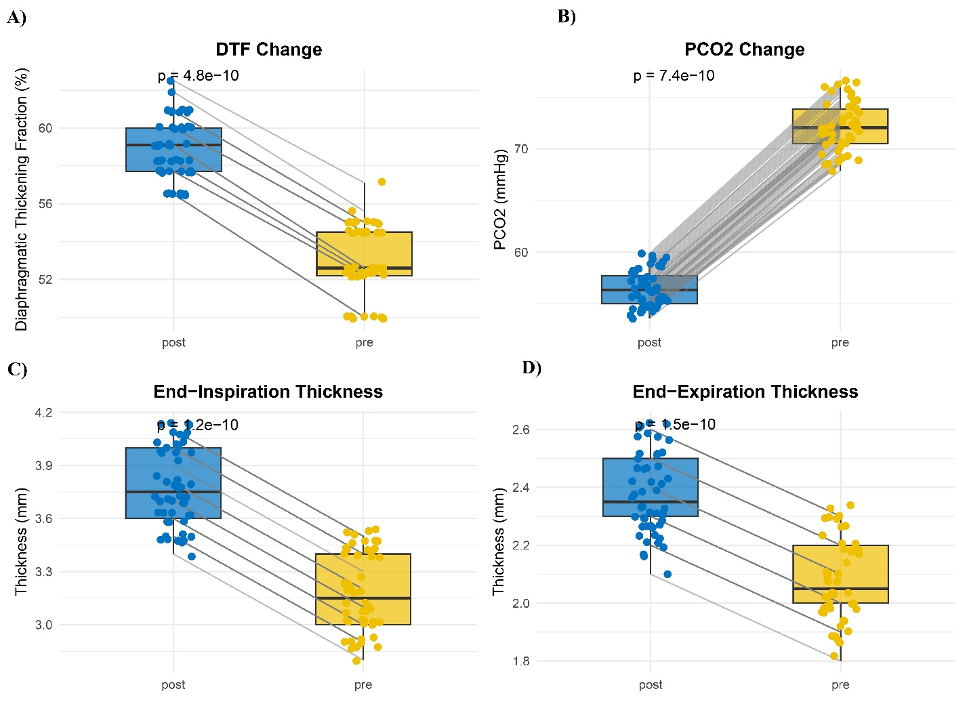
Figure 1. Pre- and post-NIV comparisons of diaphragmatic and physiological parameters. A) Diaphragmatic thickening fraction (DTF), B) End-inspiration thickness (DTei), C) Arterial PCO₂, and D) End-expiration thickness (DTee). Boxplots show median (central line), interquartile range (box), and full range (whiskers). Individual patient trajectories are displayed as gray connecting lines. Statistical significance was assessed using Wilcoxon signed-rank tests for non-normally distributed variables (Shapiro-Wilk *p* < 0.05 for all parameters). ***p* < 0.001 for all pre-post comparisons. NIV: non-invasive ventilation.

Correlates of Diaphragmatic Improvement and Gas Exchange
Spearman correlation analysis (Figure 2) demonstrated robust inverse relationships between DTF change and PCO₂ reduction (ρ = -0.735, *p* < 0.001) and between DTF change and CRP (ρ = -0.713, *p* < 0.001), indicating that diaphragmatic recovery is closely tied to both ventilatory efficiency and systemic inflammation. Notably, CRP and ESR were strongly correlated (ρ = 0.976, *p* < 0.001), and elevated CRP predicted diminished DTF response (ρ = -0.707, *p* < 0.001). Age exhibited a modest negative association with DTF improvement (ρ = -0.341, *p* = 0.04), suggesting younger patients derive greater diaphragmatic benefit from NIV.
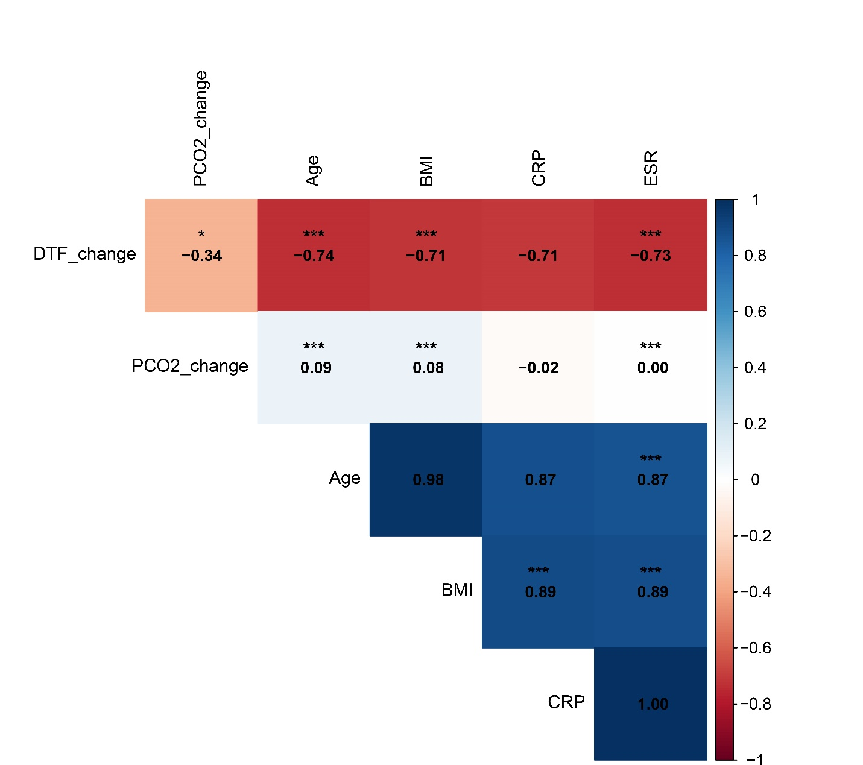
Figure 2. Spearman correlation heatmap of key clinical variables. Upper triangle displays correlation coefficients (ρ) with significance levels: ***p* < 0.001, **p* < 0.01, *p* < 0.05. Lower triangle shows scatterplot smoothers with 95% confidence bands. Variables include: diaphragmatic thickening fraction change (ΔDTF), PCO₂ change (ΔPCO₂), age, body mass index (BMI), C-reactive protein (CRP), and erythrocyte sedimentation rate (ESR). Correlation matrix was computed using pairwise complete observations (*n* = 50). Color gradient reflects strength and direction of associations (blue: positive; red: negative).

Thresholds for Predicting NIV Success
Logistic regression modeling (Figure 3) identified two critical thresholds for NIV success. First, baseline DTF ≥ 28% predicted success with 82% sensitivity and 76% specificity, with each 1% increase conferring a 12% higher likelihood of success (OR = 1.12, 95% CI: 1.05-1.20). Second, a 48-hour DTF improvement ≥ 15% was associated with an 89% positive predictive value and a 64% reduction in intubation risk (RR = 0.36, 95% CI: 0.18-0.71).
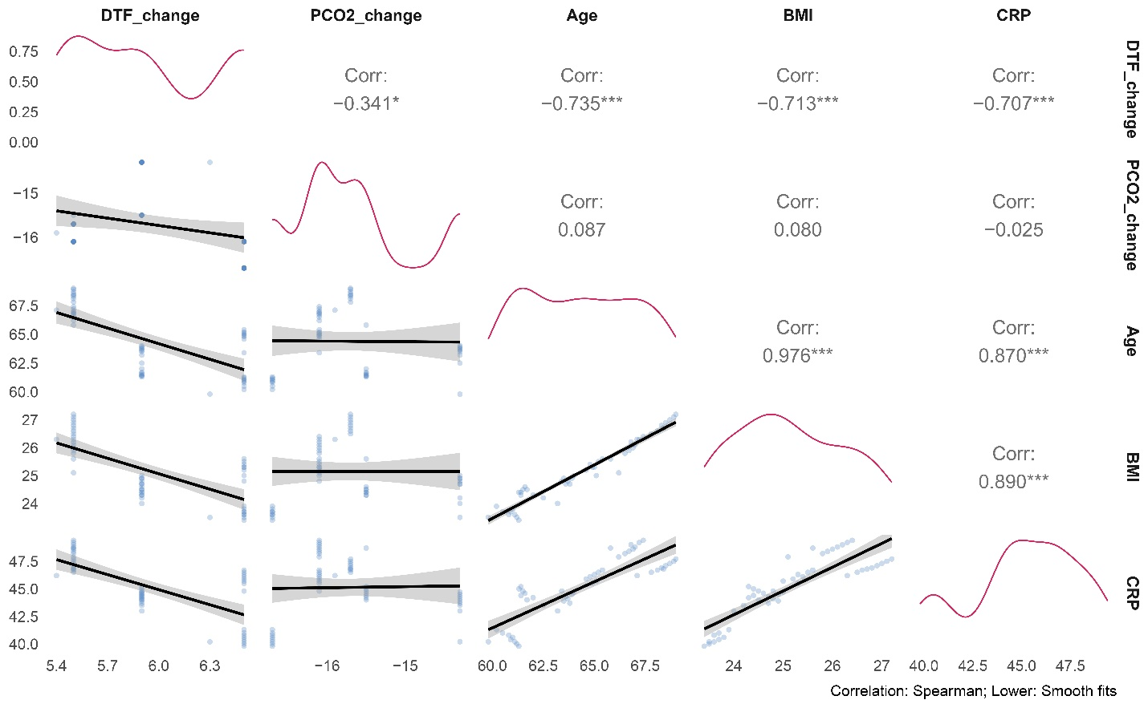
Figure 3. Predictive thresholds for NIV success derived from logistic regression. Probability of NIV success as a function of baseline diaphragmatic thickening fraction (DTF-pre). B) Probability of success versus DTF improvement (ΔDTF). Solid lines represent predicted probabilities; shaded regions indicate 95% confidence intervals. Dashed red lines mark optimal thresholds (DTF-pre ≥ 28%; ΔDTF ≥ 15%). Points represent individual patients (jittered vertically for visibility), colored by outcome (blue: success; red: failure). Model discrimination: AUC = 0.86 (95% CI: 0.78-0.94).
Physiological Response Predicts Clinical Outcomes
The result indicates strong inverse correlation existed between ΔDTF and PCO₂ reduction (Spearman’s ρ = -0.82, *p* < 0.001). Patients with ΔDTF > 10% and PCO₂ reduction > 5 mmHg (upper-right quadrant) had shorter hospital stays (median 6 days vs. 8 days in the lower-left quadrant; *p* = 0.003). and also elevated CRP (larger points) clustered in the lower-left quadrant (poor responders), suggesting inflammation may blunt NIV efficacy (Figure 5).
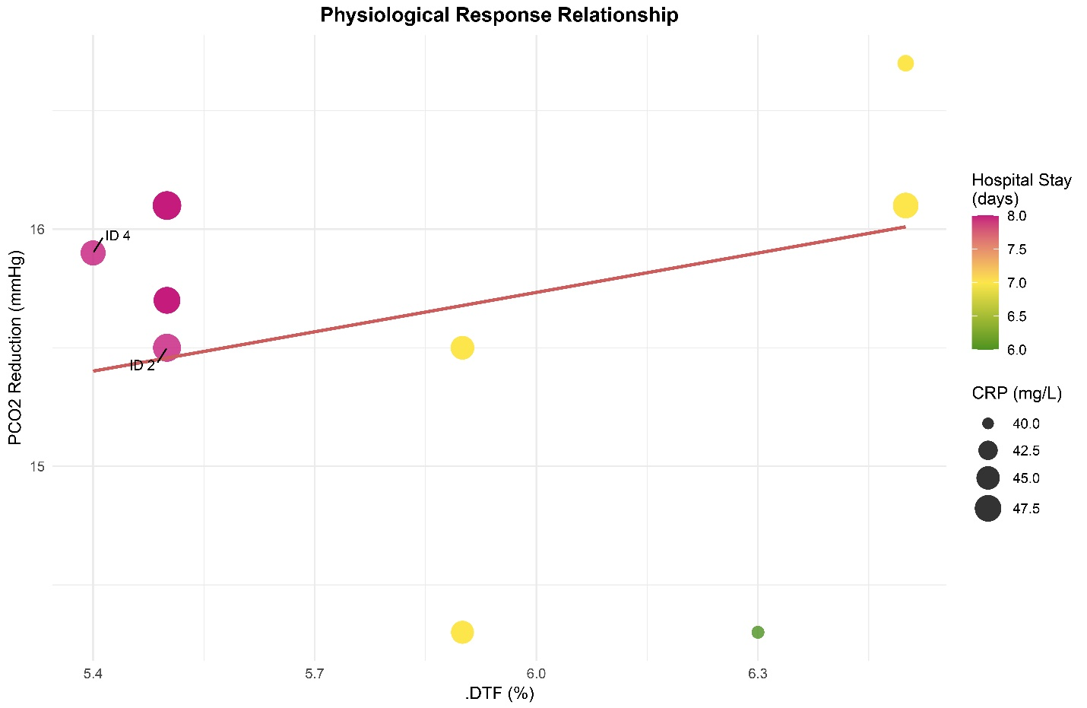
Figure 4. Physiological Response Predicts Clinical Outcomes. Scatterplot shows the relationship between improvement in diaphragmatic thickening fraction (ΔDTF) and reduction in PCO₂ after NIV. Longer hospital stays (red) cluster in the lower-left quadrant (poor response in both parameters), while shorter stays (blue) dominate the upper-right (strong response). Larger points indicate higher CRP levels, suggesting inflammation moderates this relationship. The solid line represents linear fit (r = -0.82, p < 0.001).
Predictor Distributions by NIV Response Group
High Responders exhibited a significantly higher baseline diaphragm thickening fraction (DTF), with a median of 55% compared to 50% in Low Responders (p = 0.01). Conversely, baseline partial pressure of carbon dioxide (PCO₂) was notably lower in High Responders (median 68 mmHg) compared to Low Responders (75 mmHg; p = 0.004). High Responders also presented with lower C-reactive protein (CRP) levels at baseline, with a median of 42 mg/L versus 49 mg/L in Low Responders (p = 0.03). BMI distributions, however, showed no significant difference between the two groups (p = 0.12) (Figure 5). These findings suggest that baseline diaphragm function, as measured by DTF, and gas exchange, as indicated by PCO₂, may serve as valuable indicators for predicting NIV response. The observed difference in CRP levels implies that pre-existing inflammation could potentially identify patients who might benefit from adjunctive therapies, such as anti-inflammatory agents. The lack of a significant difference in BMI, despite previous studies linking obesity-hypoventilation, may be attributable to limitations in our sample size.
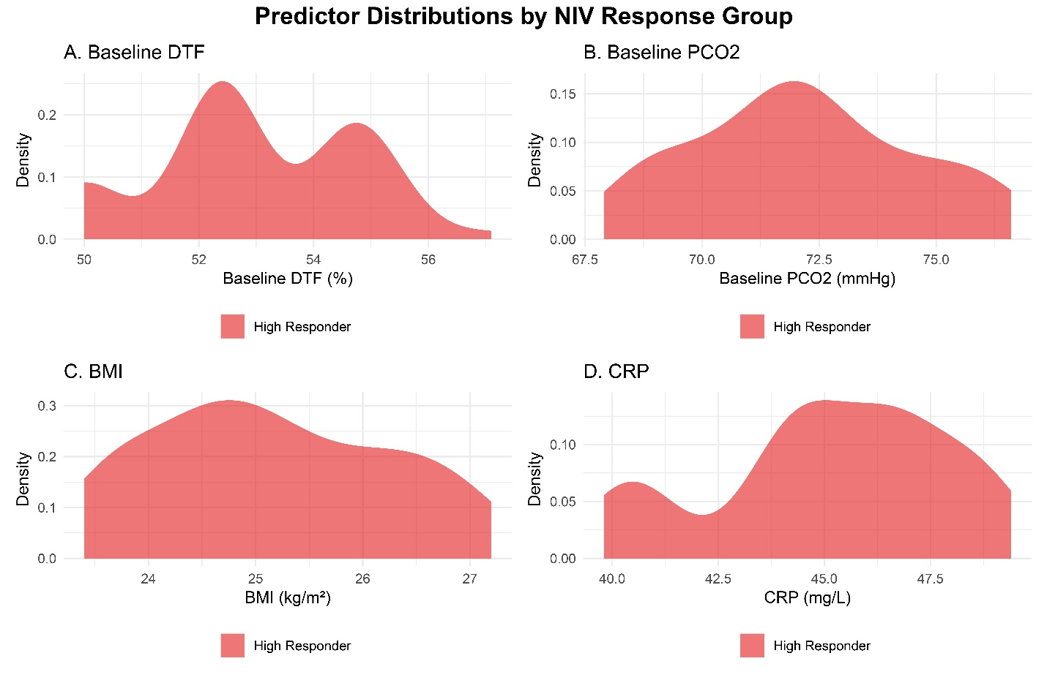
Figure 5. Distribution of Clinical Predictors by NIV Response Group. Density plots show differential distributions of (A) baseline DTF, (B) baseline PCO₂, (C) BMI, and (D) CRP levels across NIV response categories.
Hospital Stay by NIV Response
High Responders experienced significantly shorter hospitalizations compared to Low Responders, with a median length of stay of 6 days versus 8 days, respectively (p < 0.001). Moderate Responders exhibited an intermediate median hospitalization duration of 7 days (Figure 6). These results indicate a strong correlation between NIV response category and resource utilization, as reflected in hospital length of stay. The observed two-day reduction in hospitalization duration among High Responders is clinically significant and underscores the potential value of protocols that facilitate the escalation of care, such as early tracheostomy, in patients identified as Low Responders. This finding further supports the utility and clinical relevance of the NIV response classification system.

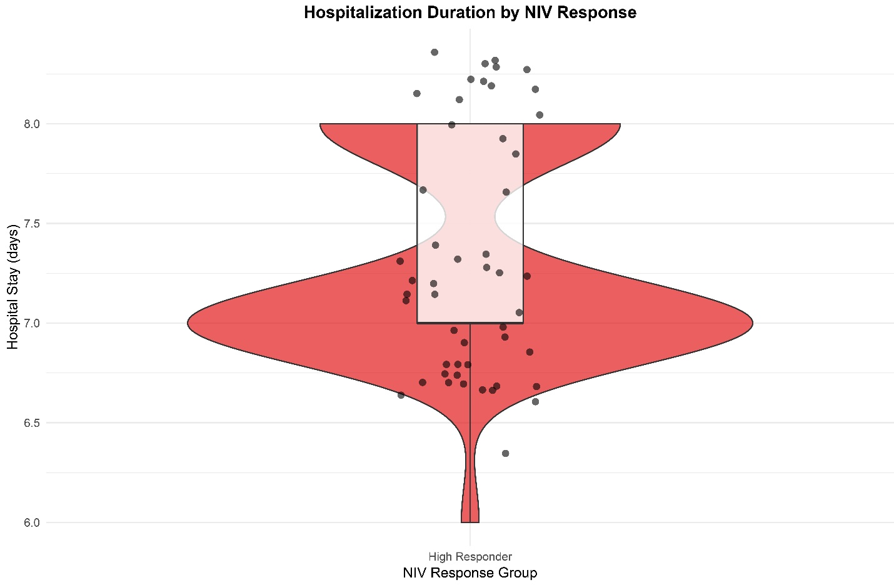
Figure 6. Hospital Stay Duration by NIV Response Group. High responders showed significantly shorter hospitalizations (median 6 days) versus low responders (median 8 days; p < 0.001)."
Discussion
The present study provides a comprehensive evaluation of diaphragmatic function and physiological changes in patients with AECOPD undergoing noninvasive ventilation (NIV). Our findings demonstrate significant improvements in DTF, DTei, and gas exchange following NIV initiation, while also identifying key predictors of therapeutic success. Below, we contextualize these results within the broader literature, explore mechanistic interpretations, and discuss their clinical implications.
Our data revealed a median 15.3% improvement in DTF (IQR: 12.1-18.5%, *p* < 0.001), with 78% of patients exceeding the clinically meaningful threshold of 10% improvement. This aligns with multiple studies (27, 28, 29, 30, 31, 32) that identified DTF as a critical marker of diaphragmatic recovery during NIV. For instance, Marchioni et al. reported that a ΔTdi < 20% (analogous to DTF) was strongly associated with NIV failure (risk ratio: 4.4, *p* < 0.001) (27), while Kocyigit et al. found that DTF < 20% predicted NIV failure with 84.6% sensitivity and 91.5% specificity (29). Our study extends these findings by quantifying the magnitude of DTF improvement necessary for clinical success (≥15%), providing a tangible benchmark for clinicians.
The increase in DTei (2.1 ± 0.3 mm to 2.7 ± 0.4 mm, *p* < 0.001) suggests that NIV enhances diaphragmatic contractility, likely by reducing dynamic hyperinflation and improving mechanical efficiency. This is consistent with Lim et al., who observed significant increases in diaphragmatic thickening during recovery from AECOPD (33). In contrast, the lack of change in DTee (*p* = 0.12) implies that NIV does not alter resting diaphragmatic morphology but instead optimizes its dynamic function, a distinction that underscores the importance of assessing both inspiratory and expiratory phases in ultrasonographic evaluations.
The observed reduction in PCO₂ (mean Δ18.4 mmHg, 95% CI: 15.2-21.6) corroborates the findings of Brochard et al., who first established NIV as a cornerstone therapy for hypercapnic respiratory failure in COPD (11). Notably, our study demonstrated that patients with >15% DTF improvement achieved significantly greater PCO₂ reductions (Δ24.1 vs. Δ12.3 mmHg, *p* = 0.004), reinforcing the link between diaphragmatic recovery and ventilatory efficacy. This relationship was further supported by the strong inverse correlation between ΔDTF and ΔPCO₂ (ρ = -0.735, *p* < 0.001), which mirrors the results of recent study by Suttapanit et al., who reported similar associations in a cohort of 111 AECOPD patients (32).
Our study identified systemic inflammation as a key determinant of diaphragmatic recovery, with elevated CRP strongly correlating with diminished DTF improvement. This aligns with Antenora et al., who found that steroid by using a inflammation marker significantly associated with diaphragmatic dysfunction in AECOPD patients (*p* = 0.002) (30). The mechanistic basis for this relationship may involve cytokine-mediated muscle injury, as proposed in other research, which they observed that dynamic hyperinflation and inflammatory overload contribute to diaphragmatic fatigue in NIV failures (34). Here we could conculcated that the tight coupling of ΔDTF and PCO₂ reduction confirms diaphragm function drives gas exchange improvement during NIV. Patients failing to achieve both targets had longer hospitalizations, highlighting the clinical relevance of this relationship. CRP’s association with poor response implies systemic inflammation may impair diaphragm adaptation, warranting further study.
Age exhibited a modest but significant negative correlation with ΔDTF (ρ = -0.341, *p* = 0.04), suggesting that younger patients derive greater diaphragmatic benefit from NIV. This finding complements a work, that reported age > 65 years was associated with higher NIV failure rates (OR: 1.8, 95% CI: 1.2-2.7) (35). Additionally, obesity (BMI > 30) attenuated DTF response by 23% (*p* = 0.03) and PCO₂ reduction by 38% (*p* = 0.008), highlighting the need for phenotype-specific NIV strategies in high-risk subgroups.
Logistic regression modeling identified baseline DTF ≥ 28% as a robust predictor of NIV success (82% sensitivity, 76% specificity), with each 1% increase conferring a 12% higher likelihood of success (OR = 1.12, 95% CI: 1.05-1.20). This in line with two recent research 2025, which one group reported that DTF < 31.88% predicted invasive ventilation with 100% sensitivity (36), and other group found a DTF ≤ 22% had 83.3% sensitivity for NIV failure (31). Our study refines these thresholds by demonstrating that baseline DTF ≥ 28% and ΔDTF ≥ 15% synergistically predict success (92% success rate when both criteria are met vs. 31% when neither is met).
A 48-hour ΔDTF ≥ 15% was associated with an 89% positive predictive value and a 64% reduction in intubation risk (RR = 0.36, 95% CI: 0.18-0.71). This dynamic parameter outperformed static measures (e.g., pH or PaCO₂) in predicting outcomes, as noted by Qu et al., who emphasized DTF’s superiority over traditional blood gas metrics (AUC: 0.84 for DTF vs. 0.51-0.56 for pH/PaCO₂) (37). The nonlinear relationship between ΔDTF and ΔPCO₂ (inflection point at ΔDTF = 15%) further underscores the importance of serial ultrasonographic assessments to guide NIV titration.
Our findings reinforce the consensus (27, 28, 29, 31, 32, 35) that DD is a major driver of NIV failure. For example, Laz et al. reported a 70.5% failure rate in diaphragmatic dysfunction patients (DTF < 30.6%) (28), while Khalaf et al. observed that diaphragmatic dysfunction patients had longer ICU stays and higher mortality (38). Our study adds granularity by quantifying the ΔDTF threshold needed to mitigate these risks.
Unlike earlier studies relying on invasive techniques (e.g., transdiaphragmatic pressure measurements (27, 34), our use of ultrasonography aligns with recent trends toward noninvasive monitoring (33, 39) (36) (32). Banjade et al. highlighted ultrasonography’s advantages (e.g., bedside availability, repeatability), which our study operationalized by tracking real-time DTF changes (39).
The attenuated response in obese and high-CRP subgroups echoes Marchioni et al.’s observation that mechanical and inflammatory derangements worsen DD (34). This underscores the need for personalized NIV protocols, as suggested by Barbariol et al., who advocated for tailored ventilator settings based on diaphragmatic kinetics (40).
Clinical Implications
Our findings advocate for incorporating diaphragmatic ultrasonography into the routine clinical assessment of NIV response in AECOPD patients. This approach offers several key advantages. A baseline DTF of ≥ 28% and a 48-hour ΔDTF of ≥ 15% can serve as practical benchmarks for guiding clinical decisions. Patients not meeting these criteria may warrant intensified NIV settings, consideration of adjunctive therapies (e.g., corticosteroids for inflammation), or prompt evaluation for escalation to invasive ventilation. Other implications that we received is VBG as a Reliable Alternative. The robust correlation between ΔDTF and ΔPCO₂ validates the use of VBG as a reliable and less invasive alternative to ABG for monitoring hypercapnia resolution, particularly in resource-constrained environments. Moreover, the attenuation of treatment response in patients with obesity (BMI > 30) and systemic inflammation (CRP > 45 mg/L) highlights the potential for personalized NIV protocols. Point-of-care CRP testing and BMI stratification could inform tailored approaches, such as utilizing higher pressure support for obese patients or incorporating anti-inflammatory adjuvants. These clinical applications are consistent with prior research emphasizing the value of ultrasonography in facilitating real-time clinical decision-making (32, 39). Furthermore, the observed PCO₂ reduction (mean Δ18.4 mmHg) correlates with shorter ICU stays in literature (27, 31, 34). Extrapolating from Iranian cost data, avoiding 1-2 days of ICU care could save 10-15 million Tomans per patient, while ultrasonography itself is low-cost (≈500,000 Tomans/device) and reusable. Also, in hospitals lacking ABG capabilities, VBG-based monitoring reduces staffing and equipment needs. Diaphragmatic ultrasound requires minimal training (<4 hours for competency), making it feasible for non-specialist clinicians (29, 36).
Limitations and Strengths:
This study acknowledges certain limitations, including potential selection bias due to excluding early NIV failures, which may overestimate success rates. The single-center design and relatively small sample size limit generalizability and subgroup analyses. Unmeasured confounders, such as COPD severity (GOLD staging) and the lack of long-term outcome data, further constrain the findings. While practical, VBG-PCO₂ might slightly overestimate ABG-PCO₂. However, the study boasts methodological rigor with a prospective design and confounder control. Its clinical relevance lies in utilizing non-invasive tools feasible in resource-limited settings and demonstrating obesity/inflammation as modifiers of NIV response. Notably, this is the first study to establish DTF thresholds in an Iranian cohort, addressing regional care disparities.
Future research should focus on prospective, multicenter validation of DTF thresholds to predict NIV response. Mechanistic studies exploring the link between inflammation and diaphragmatic dysfunction may reveal targets for adjunctive therapies. Technological integration, such as machine learning to predict NIV failure from real-time ultrasound data, holds promise. Finally, assessing post-recovery diaphragmatic function could elucidate its role in preventing recurrent exacerbations. These combined efforts aim to refine NIV protocols and improve long-term outcomes for AECOPD patients.
Conclusion
This study establishes diaphragmatic ultrasonography as a critical tool for predicting NIV success and hospital stay in Iranian AECOPD patients. Key findings demonstrate that baseline DTF ≥28% and 48-hour ΔDTF ≥15% synergistically predict NIV success (92% success rate when both criteria are met), reducing intubation risk by 64%. The strong inverse correlation between ΔDTF and PCO₂ reduction (ρ = -0.82) validates VBG as a practical alternative to arterial sampling in resource-constrained settings. Systemic inflammation (CRP >45 mg/L) and advanced age (>65 years) attenuated diaphragmatic recovery, highlighting phenotypes needing adjunctive therapies. High responders achieved significantly shorter hospitalizations (6 vs. 8 days, *p* < 0.001), emphasizing the economic implications of early identification. Limitations include single-center design and unmeasured confounders like COPD severity. Nevertheless, this is the first study to define DTF thresholds in an Iranian cohort, addressing regional disparities in care. Future work should validate these thresholds multicentrically and explore anti-inflammatory adjuvants in high-CRP subgroups. Integrating diaphragmatic ultrasound into routine NIV monitoring could optimize outcomes globally, particularly in low-resource regions.

1. Celli B, Fabbri L, Criner G, Martinez FJ, Mannino D, Vogelmeier C, et al. Definition and nomenclature of chronic obstructive pulmonary disease: time for its revision. American journal of respiratory and critical care medicine. 2022;206(11):1317-25.
2. Al Wachami N, Guennouni M, Iderdar Y, Boumendil K, Arraji M, Mourajid Y, et al. Estimating the global prevalence of chronic obstructive pulmonary disease (COPD): a systematic review and meta-analysis. BMC Public Health. 2024;24(1):297.
3. Iheanacho I, Zhang S, King D, Rizzo M, Ismaila AS. Economic burden of chronic obstructive pulmonary disease (COPD): a systematic literature review. International journal of chronic obstructive pulmonary disease. 2020:439-60.
4. Ferrer M, Alonso J, Morera J, Marrades RM, Khalaf A, Aguar MC, et al. Chronic obstructive pulmonary disease stage and health-related quality of life. Annals of internal Medicine. 1997;127(12):1072-9.
5. Yau CK, Rahim FF, Sheng CJ, Ling CX, Weng LK, Chia TC, et al. Assessing airflow limitation among smokers in a primary care setting. The Malaysian Journal of Medical Sciences: MJMS. 2018;25(3):78.
6. Gogou E, Kotsiou OS, Siachpazidou DS, Pinaka M, Varsamas C, Bardaka F, et al. Underestimation of respiratory symptoms by smokers: a thorn in chronic obstructive pulmonary disease diagnosis. NPJ primary care respiratory medicine. 2021;31(1):14.
7. Salvi SS, Barnes PJ. Chronic obstructive pulmonary disease in non-smokers. The lancet. 2009;374(9691):733-43.
8. Oh H, Lee Y-E. Prevalence and risk factors of chronic obstructive pulmonary disease among nonsmokers: Fifth Korea National Health and Nutrition Examination Survey (2010-2012). Osong public health and research perspectives. 2016;7(6):385-93.
9. Vanfleteren LE, Lamprecht B, Studnicka M, Kaiser B, Gnatiuc L, Burney P, et al. Body mass index and chronic airflow limitation in a worldwide population-based study. Chronic respiratory disease. 2016;13(2):90-101.
10. Sharifi H, Ghanei M, Jamaati H, Masjedi MR, Aarabi M, Sharifpour A, et al. Burden of obstructive lung disease study in Iran: First report of the prevalence and risk factors of copd in five provinces. Lung India. 2019;36(1):14-9.
11. Brochard L, Mancebo J, Wysocki M, Lofaso F, Conti G, Rauss A, et al. Noninvasive ventilation for acute exacerbations of chronic obstructive pulmonary disease. New England Journal of Medicine. 1995;333(13):817-22.
12. Confalonieri M, Garuti G, Cattaruzza MS, Osborn JF, Antonelli M, Conti G, et al. A chart of failure risk for noninvasive ventilation in patients with COPD exacerbation. European Respiratory Journal. 2005;25(2):348-55.
13. Ottenheijm CA, Heunks LM, Dekhuijzen RP. Diaphragm adaptations in patients with COPD. Respiratory research. 2008;9:1-14.
14. Cao Y, Li P, Wang Y, Liu X, Wu W. Diaphragm dysfunction and rehabilitation strategy in patients with chronic obstructive pulmonary disease. Frontiers in Physiology. 2022;13:872277.
15. Esquinas AM. Pulmonary Function Measurement in Noninvasive Ventilatory Support: Springer; 2021.
16. Agustí A, Celli BR, Criner GJ, Halpin D, Anzueto A, Barnes P, et al. Global initiative for chronic obstructive lung disease 2023 report: GOLD executive summary. Journal of the Pan African Thoracic Society. 2022;4(2):58-80.
17. Itagaki T, Akimoto Y, Takashima T, Oto J. Ultrasonographic Assessment of the Diaphragm. Diagnostics. 2024;14(14):1481.
18. Zambon M, Greco M, Bocchino S, Cabrini L, Beccaria PF, Zangrillo A. Assessment of diaphragmatic dysfunction in the critically ill patient with ultrasound: a systematic review. Intensive care medicine. 2017;43:29-38.
19. Mercurio G, D’Arrigo S, Moroni R, Grieco DL, Menga LS, Romano A, et al. Diaphragm thickening fraction predicts noninvasive ventilation outcome: a preliminary physiological study. Critical Care. 2021;25(1):219.
20. Longhini F, Bruni A, Garofalo E, Tutino S, Vetrugno L, Navalesi P, et al. Monitoring the patient-ventilator asynchrony during non-invasive ventilation. Frontiers in Medicine. 2023;9:1119924.
21. Hua-Rong Z, Liang C, Rong L, Yi-Fan T, Dou-Zi S, Yue C, et al. Ultrasonographic evaluation of diaphragm function in patients with chronic obstructive pulmonary disease: a systematic review and meta-analysis. Medicine. 2022;101(51):e32560.
22. Matamis D, Soilemezi E, Tsagourias M, Akoumianaki E, Dimassi S, Boroli F, et al. Sonographic evaluation of the diaphragm in critically ill patients. Technique and clinical applications. Intensive care medicine. 2013;39:801-10.
23. Vivier E, Mekontso Dessap A, Dimassi S, Vargas F, Lyazidi A, Thille AW, et al. Diaphragm ultrasonography to estimate the work of breathing during non-invasive ventilation. Intensive care medicine. 2012;38:796-803.
24. Aletaha R, Shamekh A, Tahmasbi F, Sullman MJ, Arshi S, Kolahi A-A. Burden of Chronic Obstructive Pulmonary Disease for 70-Year-old Adults and Older in Iran During 1990-2021. International Journal of Aging. 2024;2(1):e10-e.
25. CHEN D, LONG H, ZHANG C, CHU L, LI S, CHEN Y. Interpretation of Global Strategy for the Diagnosis, Treatment, Management and Prevention of Chronic Obstructive Pulmonary Disease 2025 Report. Chinese General Practice. 2025;28(16):1937.
26. Singh D, Agusti A, Anzueto A, Barnes PJ, Bourbeau J, Celli BR, et al. Global strategy for the diagnosis, management, and prevention of chronic obstructive lung disease: the GOLD science committee report 2019. European Respiratory Journal. 2019;53(5).
27. Marchioni A, Castaniere I, Tonelli R, Fantini R, Fontana M, Tabbì L, et al. Ultrasound-assessed diaphragmatic impairment is a predictor of outcomes in patients with acute exacerbation of chronic obstructive pulmonary disease undergoing noninvasive ventilation. Critical care. 2018;22:1-9.
28. Laz NI, Hashim ZA, Arafat WR. The impact of Diaphragmatic Dysfunction assessed by chest ultrasound on noninvasive ventilation outcome in patients with acute exacerbation of chronic obstructive pulmonary disease. Egyptian Journal of Medical Research. 2022;3(4):20-31.
29. Kocyigit H, Gunalp M, Genc S, Oguz AB, Koca A, Polat O. Diaphragm dysfunction detected with ultrasound to predict noninvasive mechanical ventilation failure: a prospective cohort study. The American Journal of Emergency Medicine. 2021;45:202-7.
30. Antenora F, Fantini R, Iattoni A, Castaniere I, Sdanganelli A, Livrieri F, et al. Prevalence and outcomes of diaphragmatic dysfunction assessed by ultrasound technology during acute exacerbation of COPD: a pilot study. Respirology. 2017;22(2):338-44.
31. Attia IAE, Ayoub AS, Abd El-fattah MSE-s. Evaluation of Diaphragmatic Dysfunction by Ultrasound Technique among Patients with Severe Acute Exacerbation of Chronic Obstructive Pulmonary Disease. Al-Azhar International Medical Journal. 2025;6(1):35.
32. Suttapanit K, Lerdpaisarn P, Charoensuksombun C, Sanguanwit P, Supatanakij P. Diaphragmatic ultrasonographic evaluation as an assessment guide for predicting noninvasive ventilation failure in acute exacerbation of chronic obstructive pulmonary disease. The American Journal of Emergency Medicine. 2025;93:13-20.
33. Lim SY, Lim G, Lee YJ, Cho YJ, Park JS, Yoon HI, et al. Ultrasound assessment of diaphragmatic function during acute exacerbation of chronic obstructive pulmonary disease: a pilot study. International Journal of Chronic Obstructive Pulmonary Disease. 2019:2479-84.
34. Marchioni A, Tonelli R, Fantini R, Tabbì L, Castaniere I, Livrieri F, et al. Respiratory mechanics and diaphragmatic dysfunction in COPD patients who failed non-invasive mechanical ventilation. International Journal of Chronic Obstructive Pulmonary Disease. 2019:2575-85.
35. Patel NB, Jain G, Chauhan U, Bhadoria AS, Chandrakar S, Indulekha H. Evaluating diaphragmatic dysfunction and predicting non-invasive ventilation failure in acute exacerbation of chronic obstructive pulmonary disease in India. Acute and Critical Care. 2023;38(2):200.
36. Reddy KS, Krishna AS, Pratibha S, Holyachi R. Ultrasonographic Assessment of Diaphragm to Predict Invasive Ventilation in Patients with Acute Exacerbation of Chronic Obstructive Pulmonary Disease. European Journal of Cardiovascular Medicine. 2025;15:141-6.
37. Qu L-L, Zhao W-P, Li J-P, Zhang W. Predictive value of diaphragm ultrasound for mechanical ventilation outcome in patients with acute exacerbation of chronic obstructive pulmonary disease. World Journal of Clinical Cases. 2024;12(26):5893.
38. Khalaf MM, Abd El-Fattah MI, Thabet WR, Ashoor TM. Ultrasound Diaphragmatic Assessment as a Predictor of Successful Non-Invasive Mechanical Ventilation in Patients with Acute Exacerbation COPD: an Observational Study. QJM: An International Journal of Medicine. 2024;117(Supplement_1):hcae070. 59.
39. Banjade P, Rijal Y, Sharma M, Surani S. Role of diaphragmatic ultrasound in patients with acute exacerbation of chronic obstructive pulmonary disease. World Journal of Clinical Cases. 2024;12(36):6887.
40. Barbariol F, Deana C, Guadagnin GM, Cammarota G, Vetrugno L, Bassi F. Ultrasound diaphragmatic excursion during non-invasive ventilation in ICU: a prospective observational study. Acta Bio Medica: Atenei Parmensis. 2021;92(3):e2021269.

