IRANIAN SOCIETY OF PULMONOLOGY

Board of Directors

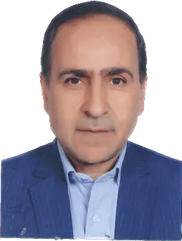

-Mostafa Ghaneei- Professor of Pulmonary Medicine- Baghiatollah University of Medical Sciences- President

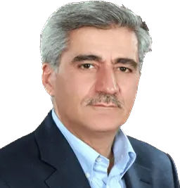
- Khalil Ansarin- Professor of Pulmonary and Sleep Medicine- Tabriz University of Medical Sciences-Director of International Program


Farid Rashidi- Associate Professor of Pulmonary and Critical Care Medicine- Tabriz University of Medical Sciences- Secretary of Association

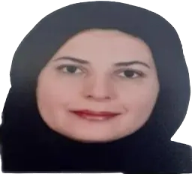

Mehrnaz Asadi Gharabaghi- Associate Professor of Pulmonary Medicine-Tehran University of Medical Sciences- Treasurer of Association
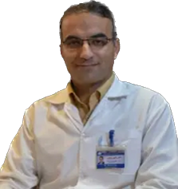

Ramin Sami- Associate Professor of Pulmonary Medicine- Isfahan University of Medical Sciences Director of Education Program
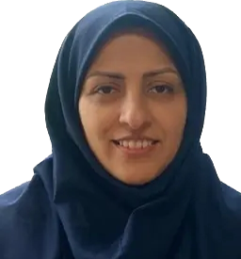
Hanieh Raji- Associate Professor of Pulmonary Medicine- Jondi shapour University of Medical Sciences Member of Association

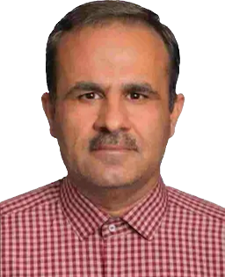
Tahmoores Niknam- Pulmonologist and Intensivist- ShiraZ University of Medical Sciences - Member of Association

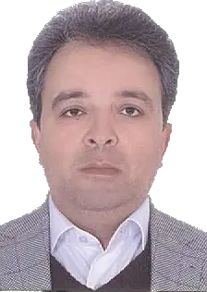

Alireza Kashefizadeh- Assistance Professor of Medicine- Shahid Beheshti University of Medical Sciences, inspector

Chairs of Departments

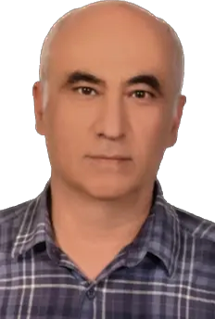
Babak Amra- Professor of Pulmonary & Sleep Medicine- Isfahan University of Medical Sciences- Director of Sleep disorders program

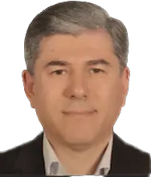
Seyyed Ali Alavi Foumani- Professor of Pulmonary Medicine- Gilan University of Medical Sciences- Director of ILD program

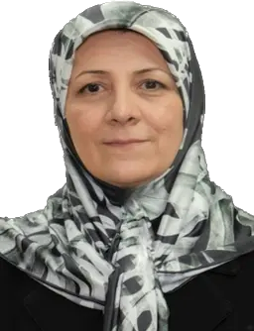
Katayoon Najafizadeh- Associate Professor of Pulmonary Medicine- Shahid beheshti University of Medical Sciences- Director of Lung Transplant program
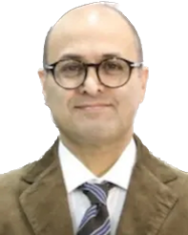

Arda Kiani- Associate Professor of Pulmonary Medicine- Shahid Beheshti University of Medical Sciences- Director of Interventional program

Ramin Sami- Associate Professor of Pulmonary Medicine- Isfahan University of Medical Sciences- Director of Airway diseases program
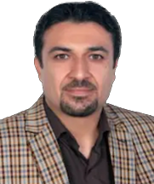

Mohammad Javad Fallahi- Assistant Professor of Pulmonary Medicine- Shiraz University of Medical Sciences- Director of critical care medicine program

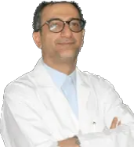

Alireza Eslaminezhad- Associate Professor of Pulmonary Medicine- Shahid Beheshti University of Medical Sciences- Director of Pulmonary FunctionTest program
Farid Rashidi- Associate Professor of Pulmonary Medicine- Tabriz University of Medical Sciences- Director of Pulmonary Vascular Diseases program
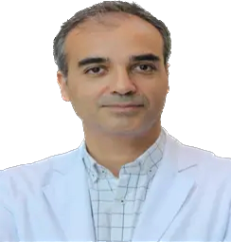
Mohsen Farrokhpoor- Assistant Professor of Pulmonary Medicine- Iran University of Medical Sciences - Director of lung cancer program

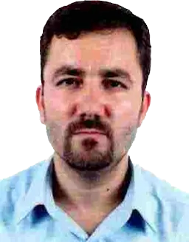

Mehdi Nadiri- Assistant Professor of Pulmonary Medicine- Tabriz University of Medical Sciences- Director of chest Ultrasound program

